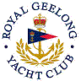 | Royal Geelong Yacht Club Inc.  Est 1859
Trophy Deed of Gift.

Trophy: | Lorna A. Anderson Trophy
Presented by: | Harold Anderson (Past Commodore)
Date: | 1950
For: | Channels Race winner by “A” Class
Remarks / Revisions | Now Division I for a nominated Race
Click here for a list of the Recipients

